

Project Report

On

Intern & HireUp

Submitted By:  
 Nikhil Jain & Ashish Agrawal  
Roll.no 20 Roll.no 49

Guided By

Prof. Sadanand Borse



**CERTIFICATE**

**CERTIFICATE**

This is to certify that **Mr. Nikhil Ramesh Jain** of **BBA – (Computer Applications)** Department, School of Management (UG), MIT World Peace University, Pune has successfully completed the project work titled “**Intern & HireUp**”, in partial fulfillment of requirement for the completion of **BBA – (Computer Applications)** course as prescribed by the University. The project report is the record of authentic work carried out by Nikhil during the period from **June 2021** to **Sept 2021**. Nikhil has worked under my guidance.

Signature: ____________ Signature: ____________

Name: Prof. Sadanand Borse Name: Prof. Kalyani Belsare  
Project Guide (Internal) Course In-charge  
Date: Date:

**CERTIFICATE**

This is to certify that **Mr. Ashish Rajendra Agrawal** of **BBA – (Computer Applications)** Department, School of Management (UG), MIT World Peace University, Pune has successfully completed the project work titled “**Intern & HireUp**”, in partial fulfillment of requirement for the completion of **BBA – (Computer Applications)** course as prescribed by the University. The project report is the record of authentic work carried out by Ashish during the period from **June 2021** to **Sept 2021**. Ashish has worked under my guidance.

Signature: ____________ Signature: ____________

Name: Prof. Sadanand Borse Name: Prof. Kalyani Belsare  
Project Guide (Internal) Course In-charge  
Date: Date:

**Student Information**

|  |  |  |
| --- | --- | --- |
| SR.NO | Particulars | Details |
| 1. | Student Name | Nikhil Jain & Ashish Agrawal |
| 2. | Roll.No | 20 & 49 |
| 3. | Guide’s Name | Prof. Sadanand Borse |
| 4. | Programme Name | Bachelor Of Business Administration (Computer Applications) |
| 5. | Trimester | 07 |
| 6. | Course Code | BBC304A |
| 7. | Project Title | Intern & HireUp |

**ACKNOWLEDGEMENT**

**ACKNOWLEDGEMENT**

We are glad to take this opportunity to acknowledge all those who helped us in developing and in successful completion of our project titled

“Intern & HireUp”

We would like to extend our thanks to our project guide Prof. Sadanand Borse sir and for his valuable guidance and timely assistance throughout the development of the project.

We would also like to extend our thanks to the Course In-Charge Prof. Kalyani Belsare without whose help and support this project would not have been possible. We are also really thankful to all our friends who advised and motivated us throughout the course.

Thanking You in Anticipation,

Nikhil Jain Ashish Agrawal

Roll.no 20 Roll.no 49

**ABSTRACT**

ABSTRACT

The Project named Intern & HireUp is developed as an attempt to take personal, academic and skills records of student and making it available for the college administrator. The system provide the facility of viewing personal, academic and skills details of the student as well as generated resume for college administrator. It also provides the facility to search for student records and print reports.

The application, as described above, can lead to error free, secure, reliable and fast management of the data. It can assist the user to concentrate on their other activities rather to concentrate on the record keeping. Thus it helps organization in better utilization of resources. The organization can maintain computerized records without redundant entries. That means that one need not be distracted by information that is not relevant, while being able to reach the information.

Table of Contents

Synopsis 8

Introduction 8

Scope of the project 8

Objective of the project 9

Hardware and Software Requirements 9

Functional and Non-Functional Requirements 10

Requirement Gathering 10

System Design 11

DFD – Context Level Diagram 11

DFD – Level 1 12

ERD – Entity Relationship Diagram 13

Data Dictionary 14

Admin Table 14

Login Table 14

Contacts Table 14

Student Personal Detail Table 15

Company Table 15

Student Academic Detail Table 16

Skills Table 17

User Interface Design 18

Future Enhancement 29

# Synopsis

## Introduction

The Intern & HireUp project is a web based application. It is a platform where student can register, add, view, edit, delete, and maintain their information. The system is developed using Core Java and JSP, and uses MySQL for database management.

The database can be access by college Administrator. Administrator has rights to view student records such as personal, academic, skills and generated resume. The system provides the facility to search for the student records and display the list of candidate as well as allow printing necessary records.

The Intern & HireUp also provide facility to store information error free, securely, accurately, and making the information accessible as and when required. Also the system is flexible enough to meets any future requirements.

## Scope of the project

The project titled ‘Intern & HireUp’ is an application developed that is intended to be use by college. The college can provide this application to their students from the 1st year of their respective courses. The student can register and maintain their personal and academic details. If suppose any company want to provide internship to students, then using the application, the college admin can provide the student records and also maintain the records of students that are selected for internship.

In case if the company wants records of students for the placement purpose, then college admin can provide the records of the student accordingly and if any student is placed then application provide the facility to maintain such records as well.

## Objective of the project

The main objective of the project Intern & HireUp is to maintain student personal, academic, and skills details with error free, secure, reliable and fast management of data. The application helps generate resume based on the student information, which can be access by college Administrator and provide facility to print the necessary records.

The purpose of the project is to build an application to reduce the manual work for managing all the student records. It also allows searching for the student records.

## Hardware and Software Requirements

❖ Hardware:

|  |  |
| --- | --- |
| Name of Component | Specification |
| Processor | Intel i3 and above |
| Processor Speed | 1.6 Hz and above |
| RAM Size | 2GB and above |
| Hard Disk | 2.5GB and above |

❖ Software:

|  |  |
| --- | --- |
| Name of Component | Specification |
| Operating System | Microsoft Windows 7 and above |
| Language | Core Java, JSP, CSS, JS(Basic) |
| Browser | Chrome, Internet Explorer, Firefox, etc |
| Web Server | Apache Tomcat 7 and above |
| Software Development Kit | Java JDK 1.8 and above |
| Database JDBC Driver | MySQL Connector Java |

## Functional and Non-Functional Requirements

**FUNCTIONAL REQUIREMENT:**

* Student must be able to register and login to the application.
* Student must be able to add personal, academic, and skills details.
* Application must be able to generate student resume based on entered data.
* Admin should be able to view the student records and print necessary records
* Application should also provide the facility for admin to view generated resume.

**NON-FUNCTIONAL REQUIREMENT:**

* Student must be login to access the application
* Data should be store securely and should be accessible as and when required.
* The application must have user-friendly interface.
* Website should not take lots of time to load.

## Requirement Gathering

This document describes the requirement for the Intern & HireUp project.

The proposed system has the following requirements:

* Application needs to store student personal, academic, and skills details.
* Application needs to help the admin to view, search, print student records and also allows access to generated resume.
* Application need to maintain quality records
* Application need to keep the record of Student.
* Application should allow student to update and delete the record.
* Application should not allow duplicate entry of records.

# System Design

## DFD – Context Level Diagram

A context diagram, sometimes called a level 0 data-flow diagram, is drawn in order to define and clarify the boundaries of the Intern & HireUp Application. It identifies the flows of information between the system and external entities. The entire application is shown as a single process.

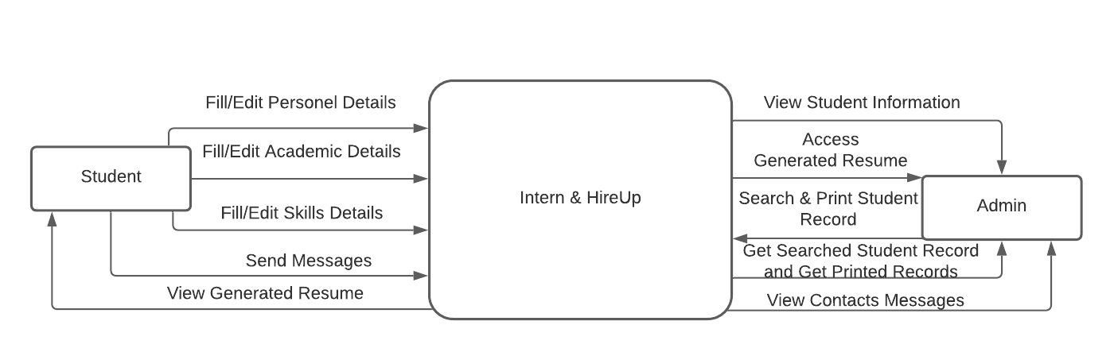

## DFD – Level 1

Level 1 DFD define an “exploded view” of the context diagram. It highlights main functions of the Intern & HireUp Application. Visualize incoming data flow, processes and output data flows.

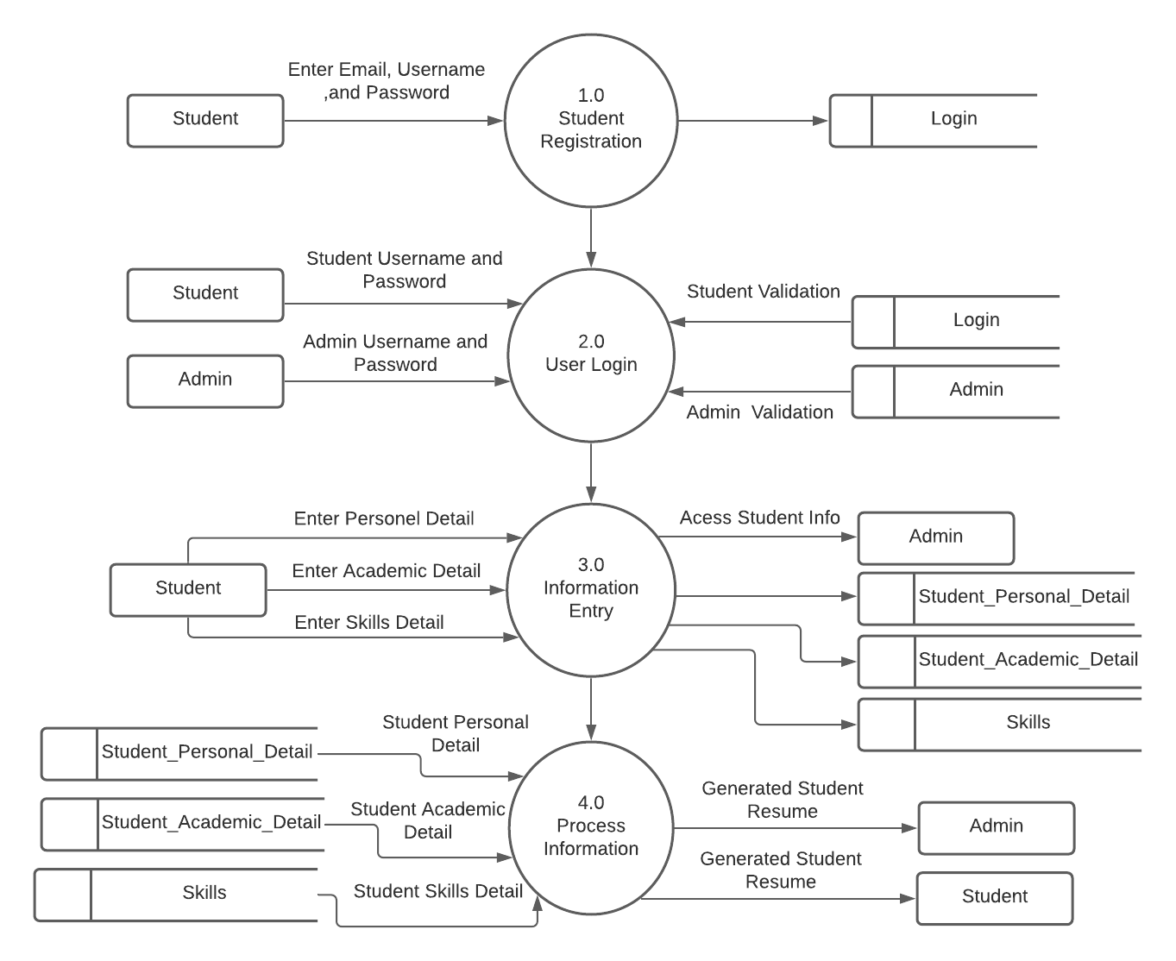

## ERD – Entity Relationship Diagram

Here, The Entity Relationship Diagram displays the relationship of entity sets stored in the Intern & HireUp database. It helps to explain the logical structure of the project database.

ER diagrams are basically the combination of entities, attributes and relationships. ‘Entity’ is any real-life entity, ‘Attributes’ define properties or characteristics of an entity, and ‘Relationship’ is an association between one or more entity.

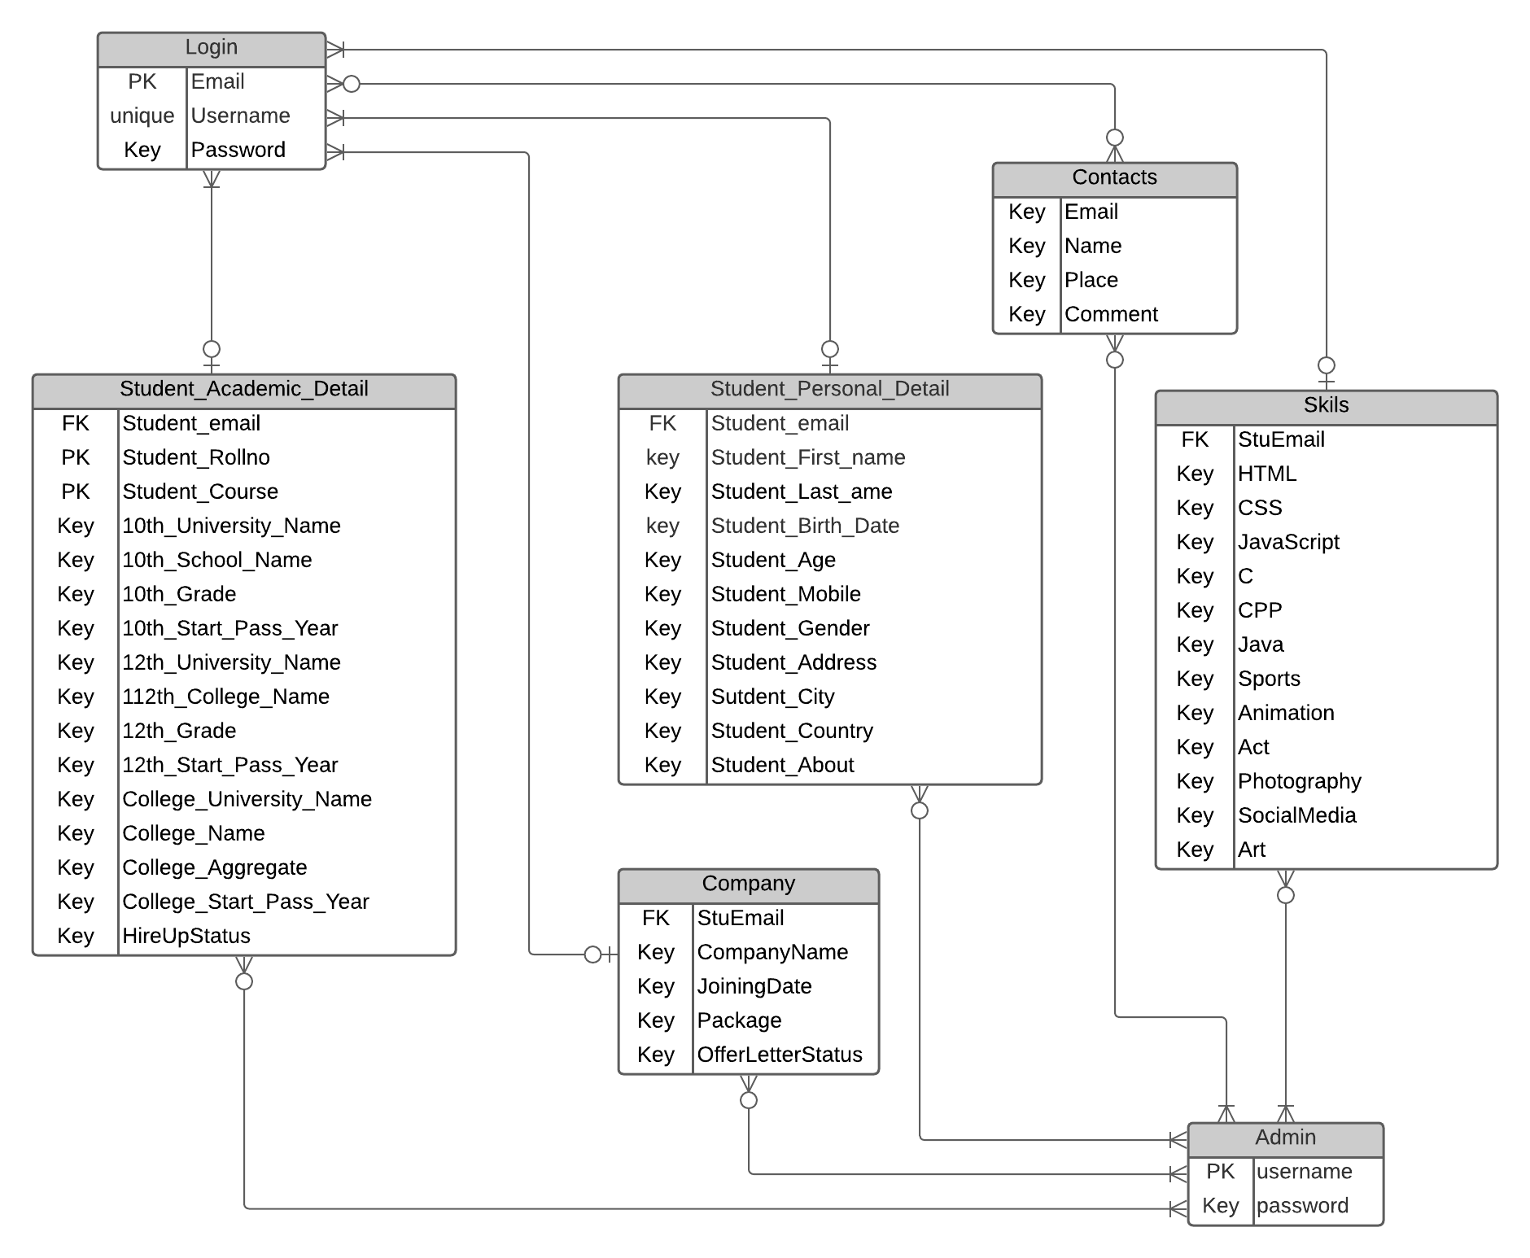

# Data Dictionary

## Admin Table

|  |  |  |  |  |  |
| --- | --- | --- | --- | --- | --- |
| **Attributes** | **Data-Type** | **Constraints** | **Control** | **Validations** | **Description** |
| Username | VARCHAR(50) | PRIMARY KEY, NOT NULL | Type text field | Unique & Non empty | Admin username |
| Password | VARCHAR(20) | NOT NULL | Type password field | Non Empty | Admin Password |

## Login Table

|  |  |  |  |  |  |
| --- | --- | --- | --- | --- | --- |
| **Attributes** | **Data-Type** | **Constraints** | **Control** | **Validations** | **Description** |
| Email | VARCHAR(320) | PRIMARY KEY | Type Email Field | Non-Empty | Student Email |
| Username | VARCHAR(50) | UNIQUE, NOT NULL | Type text field | Unique & Non empty | Account username |
| Password | VARCHAR(20) | NOT NULL | Type password field | Non Empty | Account Password |

## Contacts Table

|  |  |  |  |  |  |
| --- | --- | --- | --- | --- | --- |
| **Attributes** | **Data-Type** | **Constraints** | **Control** | **Validations** | **Description** |
| ContactName | VARCHAR(50) | NOT NULL | Type Text Field | Non Empty | User Name |
| ContactEmail | VARCHAR(320) | NOT NULL | Type Email Field | Non Empty | User Mail Id |
| ContactPlace | VARCHAR(20) | NOT NULL | Type Text Field | Non Empty | User Place Name |
| ContactComment | LONGTEXT | None | Type Text Field | None | User Comment |
| ContactStatus | VARCHAR(20) | NOT NULL, DEFAULT 'unread' | NONE | None | Contact Read/Unread Mark |

## Student Personal Detail Table

|  |  |  |  |  |  |
| --- | --- | --- | --- | --- | --- |
| **Attributes** | **Data-Type** | **Constraints** | **Control** | **Validations** | **Description** |
| StuEmail | **Foreign Key --> Login table** | | | | |
| StuFirstName | VARCHAR(50) | NOT NULL | Text Field | Non-Empty | Student First Name |
| StuLastName | VARCHAR(50) | NOT NULL | Text Field | Non-Empty | Student Last Name |
| StuBirthDate | VARCHAR(12) | NOT NULL | Date | Non-Empty | Student Birth Date |
| StuAge | INT | NOT NULL | NONE | NONE | Student Age |
| StuMobile | VARCHAR(20) | NOT NULL | Tel-Field | Non-Empty | Student Mobile Number |
| StuGender | ENUM('M', 'F', 'O') | NOT NULL | Radio Button | Non-Empty | Student Gender |
| StuAddress | VARCHAR(300) | NOT NULL | Text Field | Non-Empty | Student Address |
| StuCity | VARCHAR(50) | NOT NULL | Text Field | Non-Empty | Student City |
| StuCountry | VARCHAR(50) | NOT NULL | Text Field | Non-Empty | Student Country |
| StuAbout | VARCHAR(500) | NOT NULL | TextArea | Non-Empty | More About Student |

## Company Table

|  |  |  |  |  |  |
| --- | --- | --- | --- | --- | --- |
| **Attributes** | **Data-Type** | **Constraints** | **Control** | **Validations** | **Description** |
| stuEmail | **Foreign Key --> Login table** | | | | |
| CompanyName | VARCHAR(500) | NOT NULL | Type Text Field | Non Empty | Company Name |
| JoiningDate | VARCHAR(20) | NOT NULL | Type Date | Non Empty | Company Joining Date |
| Package | VARCHAR(20) | NOT NULL | Type Text Field | Non Empty | Package value |
| OfferLetterStatus | VARCHAR(20) | ENUM('Received', 'Not-Received'), NOT NULL, | Select | Non Empty | Offer Letter Status either Recived or Not-Received |

## Student Academic Detail Table

|  |  |  |  |  |  |
| --- | --- | --- | --- | --- | --- |
| **Attributes** | **Data-Type** | **Constraints** | **Control** | **Validations** | **Description** |
| stuEmail | **Foreign Key --> Login table** | | | | |
| StuRollNo | INT | Composite PRIMARY KEY | Text-Field | Unique | Student Roll no |
| StuCourse | ENUM('BBA', 'BBA(CA)', 'BBA(GeB)', 'BBA(IB)') | Select | Non-Empty | Student Course |
| 10th_University_Name | VARCHAR(300) | NOT NULL | Text-Field | Non-Empty | Student 10th University Name |
| 10th_School_Name | VARCHAR(300) | NOT NULL | Text-Field | Non-Empty | Student 10th School Name |
| 10th_Grade | ENUM('A', 'B', 'C', 'D') | NOT NULL | Select | Non-Empty | Student 10th Grade |
| 10th_Start_Pass_Year | VARCHAR(15) | NOT NULL | Text-Field | Non-Empty | Student 10th Start Year |
| 12th_University_Name | VARCHAR(300) | NOT NULL | Text-Field | Non-Empty | Student 12th University Name |
| 12th_School_Name | VARCHAR(300) | NOT NULL | Text-Field | Non-Empty | Student 12th School Name |
| 12th_Grade | ENUM('A', 'B', 'C', 'D') | NOT NULL | Select | Non-Empty | Student 12th Grade |
| 12th_Start_Pass_Year | VARCHAR(15) | NOT NULL | Text-Field | Non-Empty | Student 12th Start Year |
| College_University_Name | VARCHAR(300) | NOT NULL | Text-Field | Non-Empty | Student college University Name |
| College_School_Name | VARCHAR(300) | NOT NULL | Text-Field | Non-Empty | Student college School Name |
| College_Aggregate | ENUM('A', 'B', 'C', 'D') | NOT NULL | Select | Non-Empty | Student College Aggregate |
| College_Start_Pass_Year | VARCHAR(15) | NOT NULL | Text-Field | Non-Empty | Student college Start Year |
| HireStatus | ENUM('Not-Selected', 'Selected') | NOT NULL, Default 'Not-Selected' | None | Non-Empty | Student Company Hire Status either Selected or Not-Selected |

## Skills Table

|  |  |  |  |  |  |
| --- | --- | --- | --- | --- | --- |
| **Attributes** | **Data-Type** | **Constraints** | **Control** | **Validations** | **Description** |
| stuEmail | **Foreign Key --> Login table** | | | | |
| HTML | INT | NOT NULL | Type Number-field | Required, Range (1 t0 100) | HTML Skills in percentage |
| CSS | INT | NOT NULL | Type Number-field | Required, Range (1 t0 100) | CSS Skills in percentage |
| JavaScript | INT | NOT NULL | Type Number-field | Required, Range (1 t0 100) | JavaScript Skills in percentage |
| C | INT | NOT NULL | Type Number-field | Required, Range (1 t0 100) | C Programming Skills in percentage |
| CPP | INT | NOT NULL | Type Number-field | Required, Range (1 t0 100) | CPP Programming Skills in percentage |
| Java | INT | NOT NULL | Type Number-field | Required, Range (1 t0 100) | Java Programming Skills in percentage |
| Sports | INT | NOT NULL | Type Number-field | Required, Range (1 t0 100) | Sports Skills in percentage |
| Animation | INT | NOT NULL | Type Number-field | Required, Range (1 t0 100) | Animation Skills in percentage |
| Act | INT | NOT NULL | Type Number-field | Required, Range (1 t0 100) | Act Skills in percentage |
| Photography | INT | NOT NULL | Type Number-field | Required, Range (1 t0 100) | Photography Skills in percentage |
| SocialMedia | INT | NOT NULL | Type Number-field | Required, Range (1 t0 100) | Social Media Skills in percentage |
| Art | INT | NOT NULL | Type Number-field | Required, Range (1 t0 100) | Art Skills in percentage |

# User Interface Design

## Intern & HireUp Home Page



## Sign Up Page

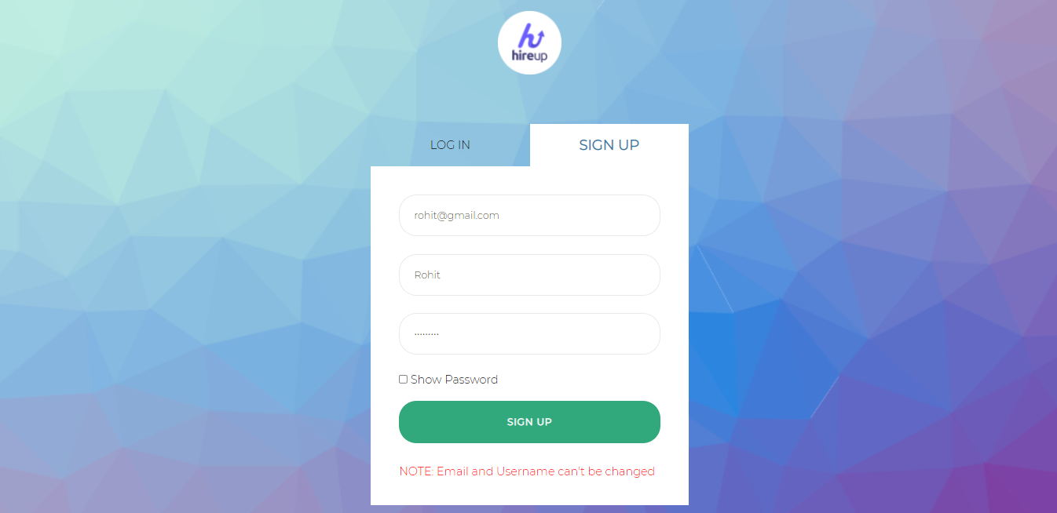

## Login Page

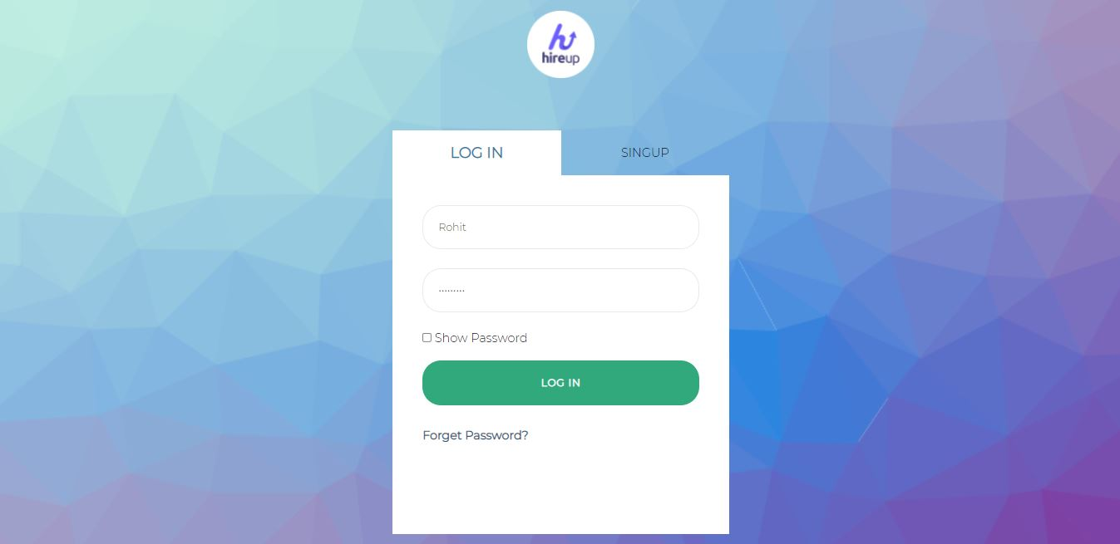

## Student – Add Personal Detail

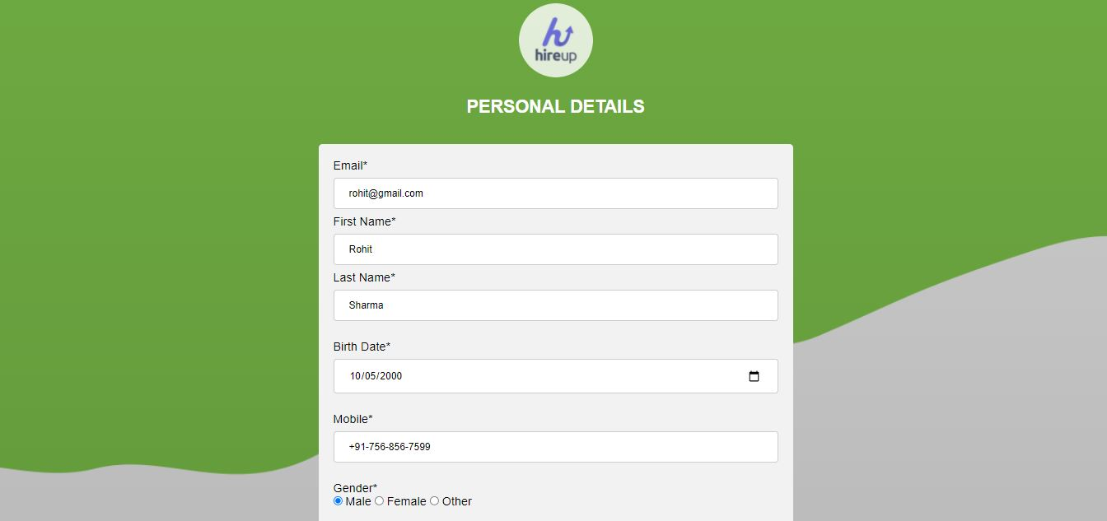

## Student – Add Academic Details

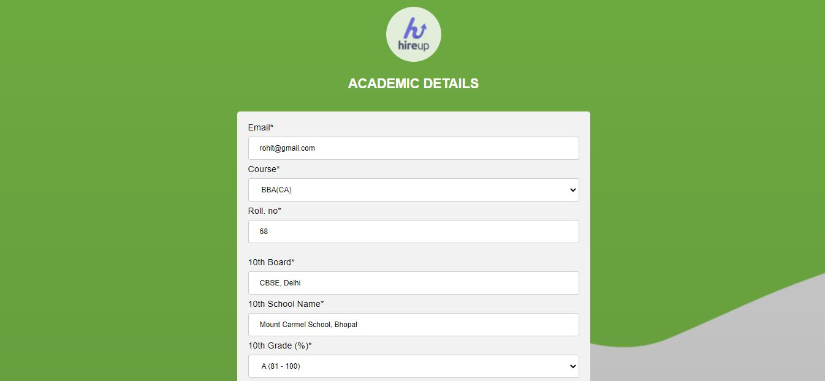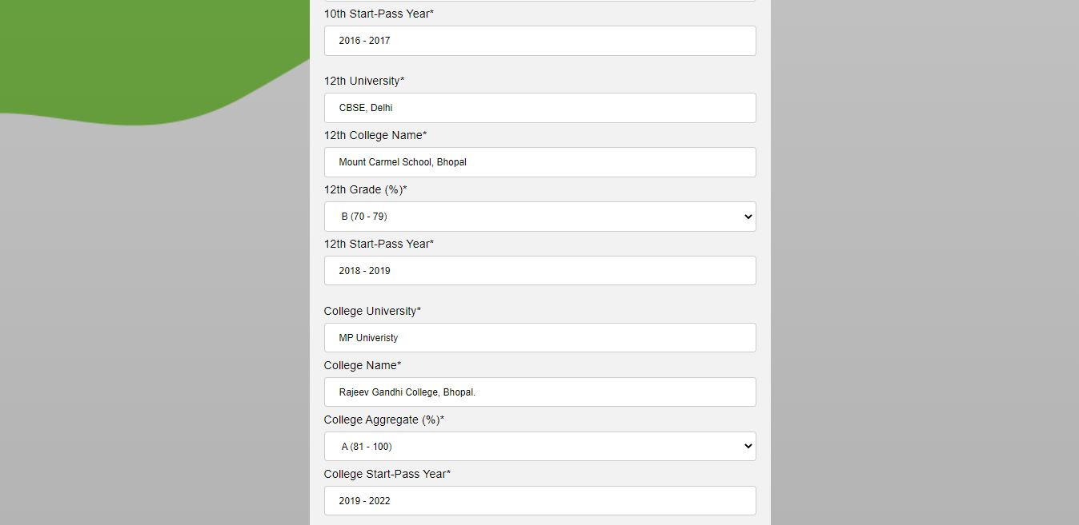

## Student – Add Skills Details

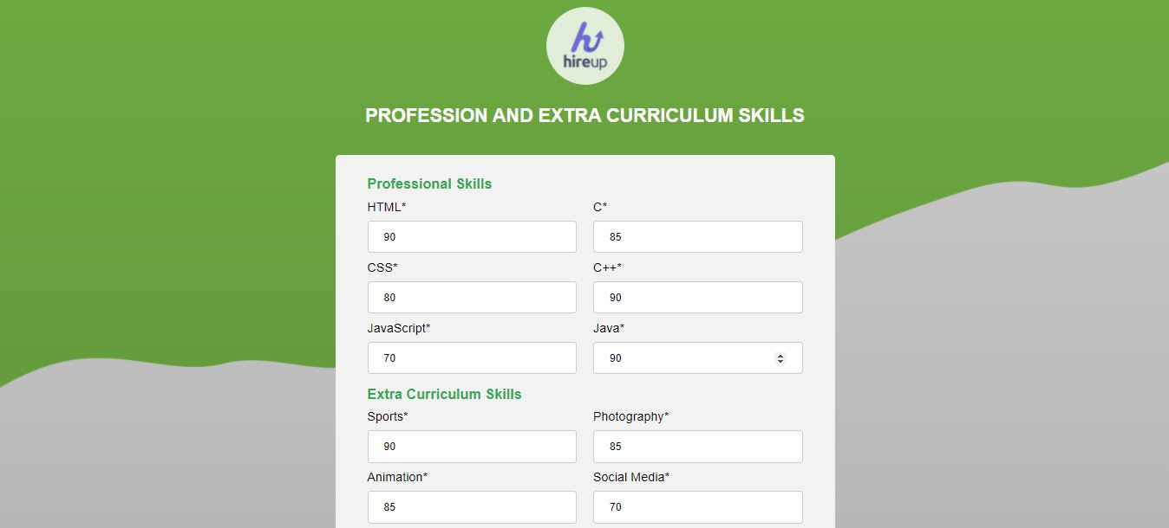

## Student Home Page

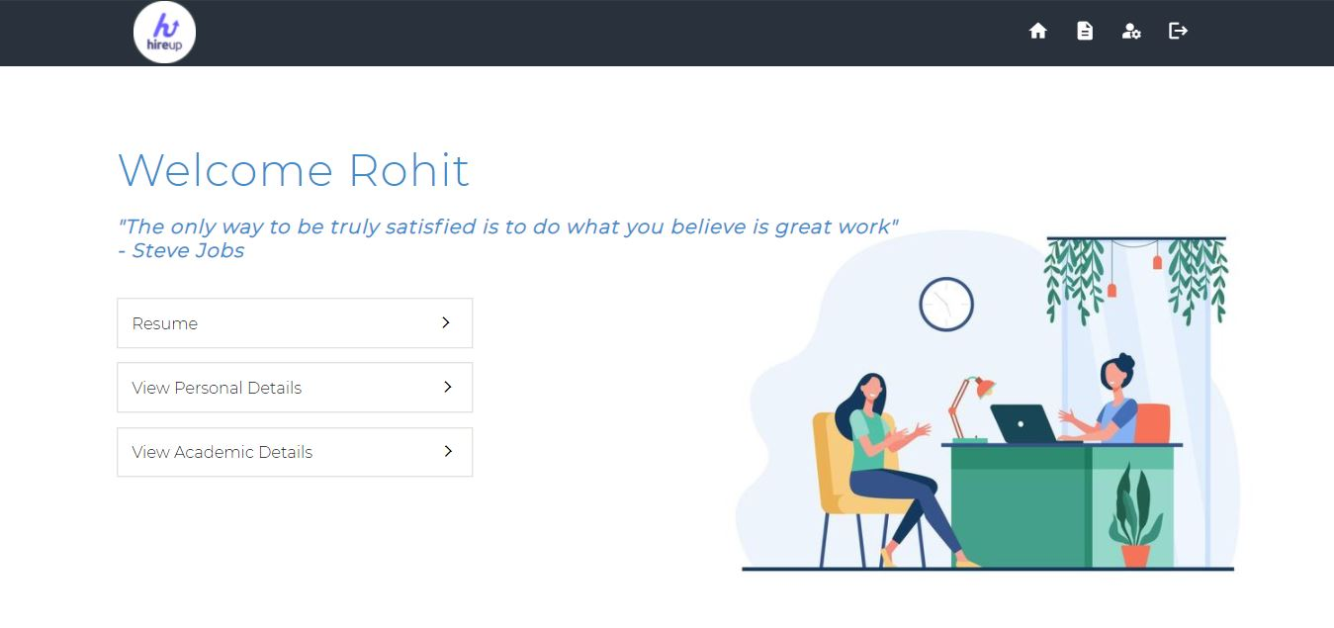

## Student Personal Detail

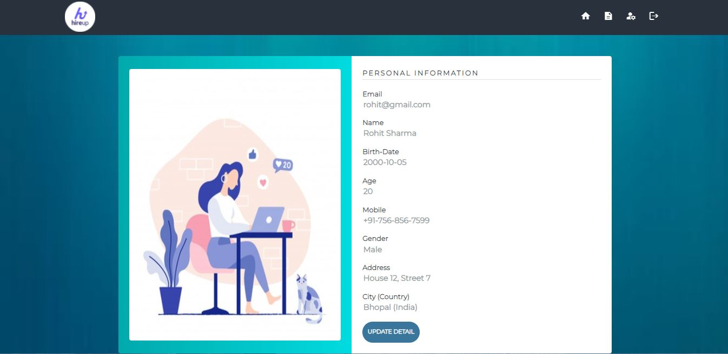

## Student Academic Detail

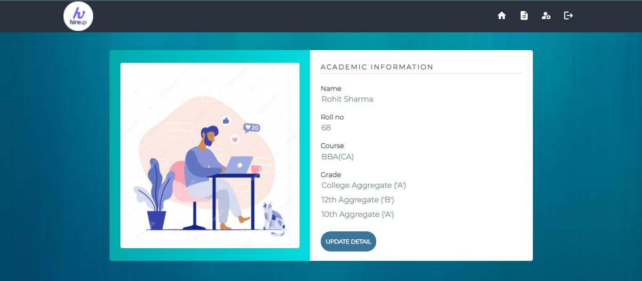

## Student Setting Page

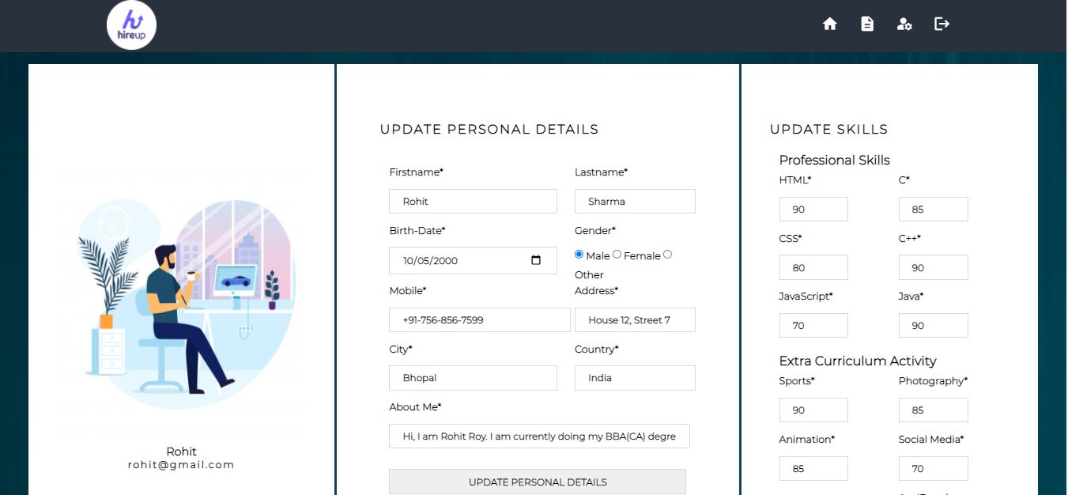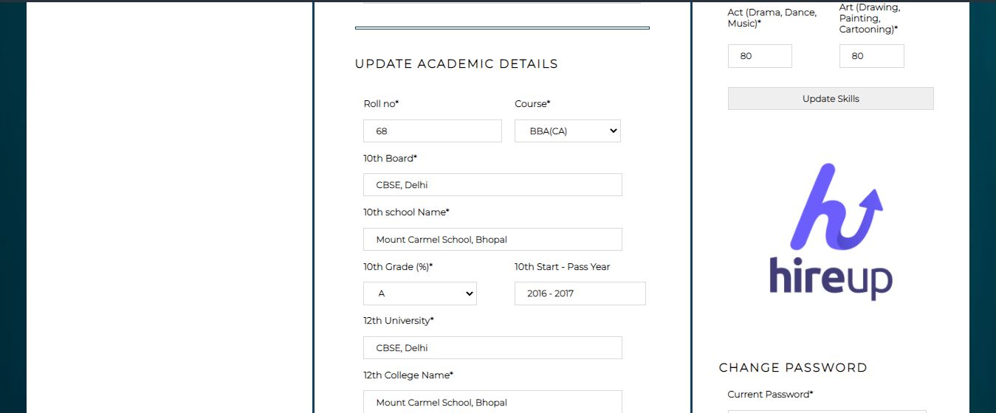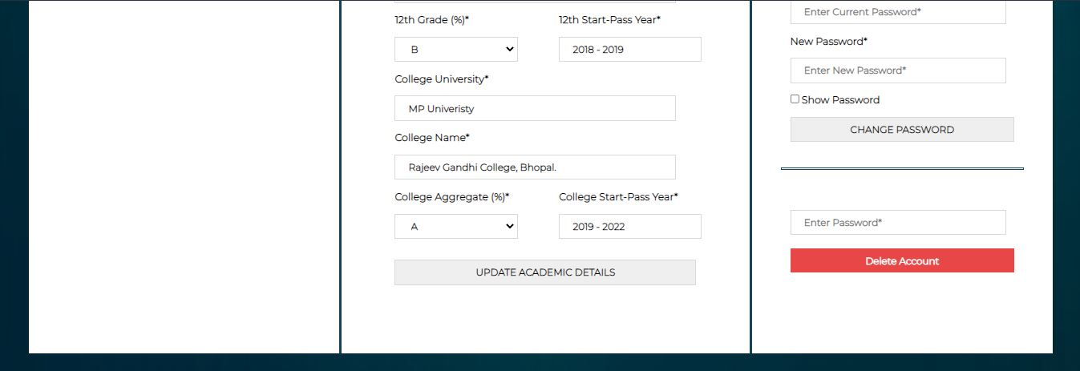

## Student – View Resume Page

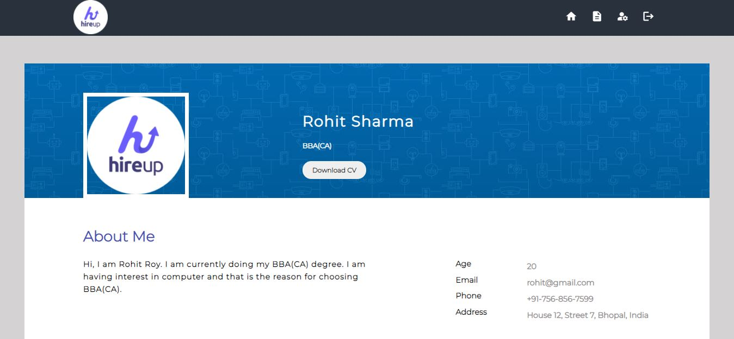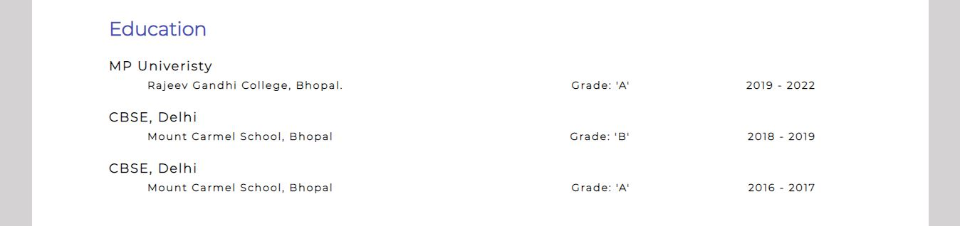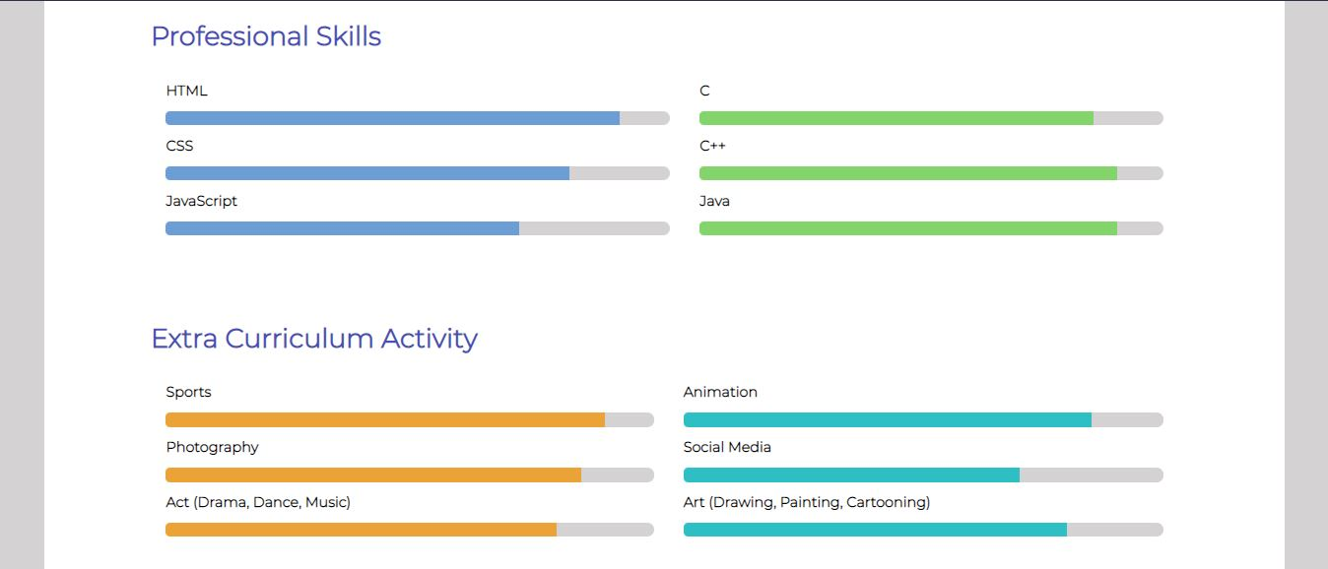

## Admin – Home Page

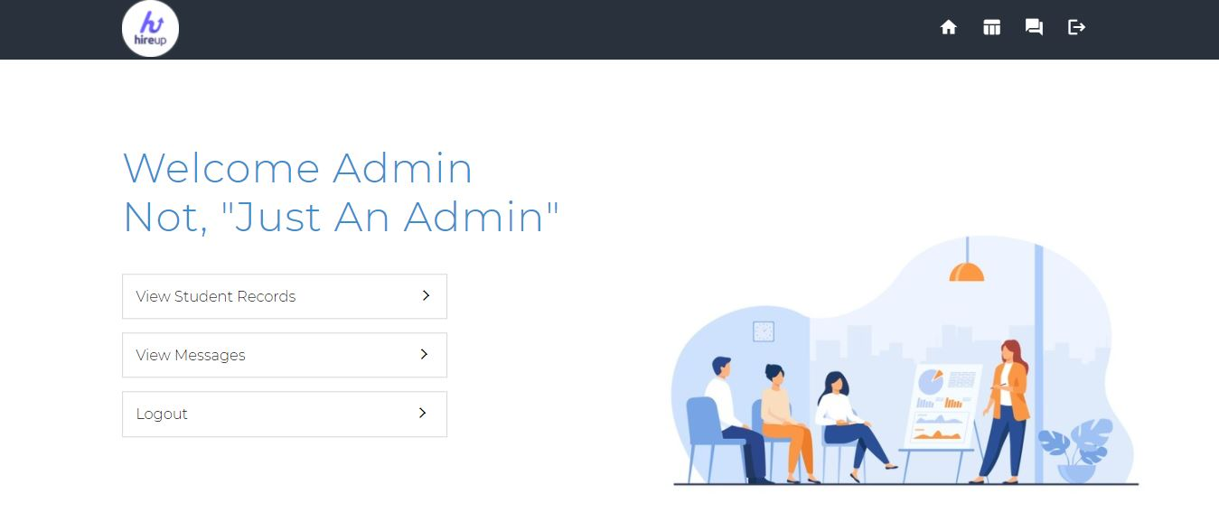

## Admin – View All Students Record

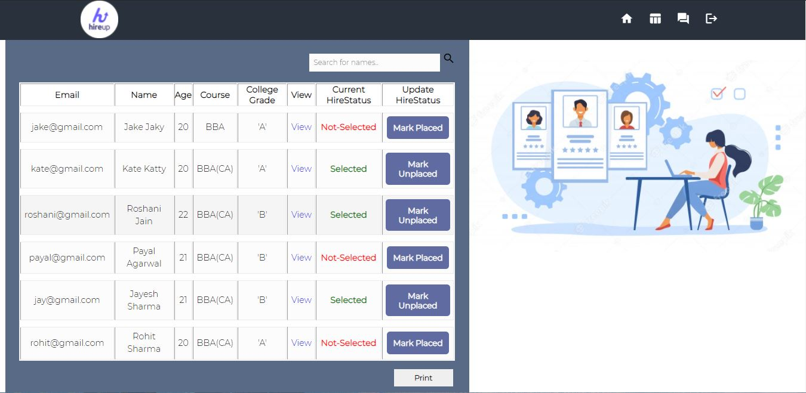

## Admin – View Only Selected Students Record

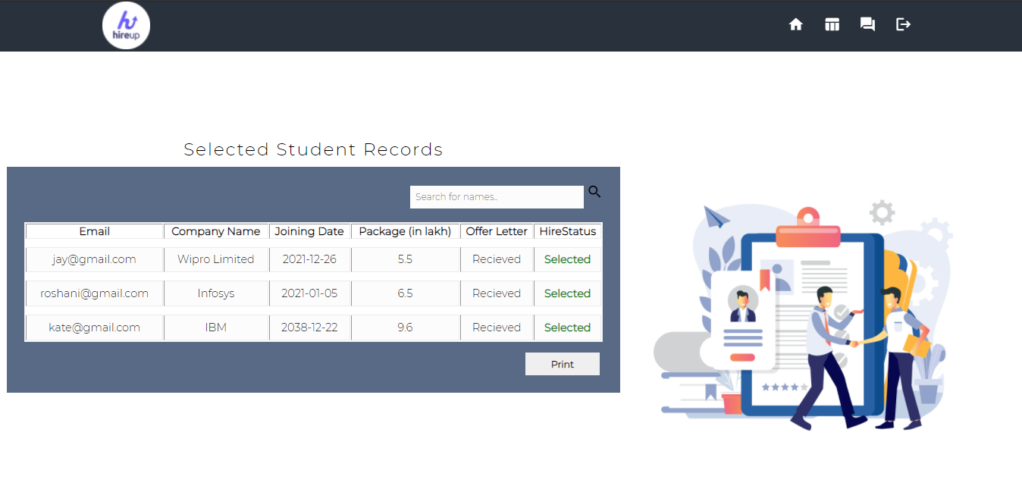

## Admin – View Contacts Messages

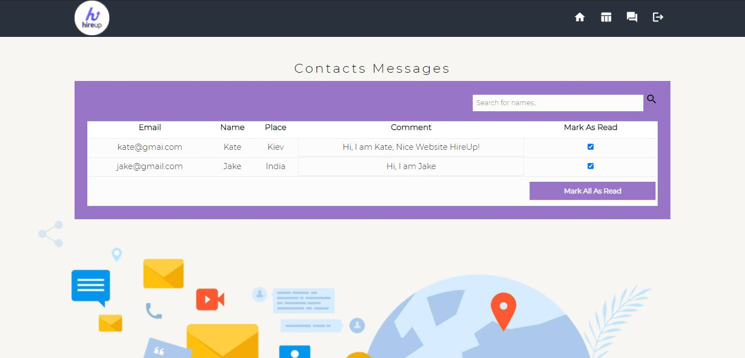

# Future Enhancement

As this is an infant level project it has limited functionalities, the future enhancements however will be integrating additional features into the project to make it more user friendly, some of them are as follows:-

* Minor bugs and errors will be fixed in the future.
* We can add option to upload profile image for student.
* We can add option to upload resume for student.
* We can add option to download resume for both student and admin.
* We can add filter option for admin to search records based on filter criteria.
* We can add option to download multiple resume at a time for admin.

The above mentioned points are the enhancements which can be done to increase the applicability and usage of this project. In the last we would like to thanks all the persons involved in the development of the system directly or indirectly. We hope that the project will serve its purpose for which it is develop there by underlining success of process.